CheaperOfficeFurniture.net Announces Year-End Savings

Released on: November 17, 2008, 12:21 pm
Press Release Author: Jean-Pierre Cruz
Industry: Consumer Services
Press Release Summary: Southern California’s best deals on office furniture is available online
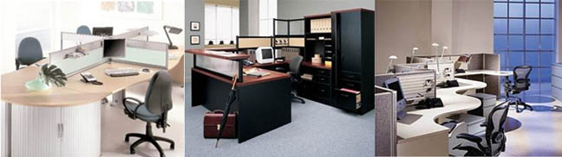
Press Release Body: Gardena, Calif., November 10, 2008 — CheaperOfficeFurniture.net, the Internet’s most affordable selection of discount office furniture announced some of the most competitive prices on office furniture, workstations and cubicles for any size and any type of office environment. Customers can find savings on new, remanufactured and pre-owned office furniture, or consign existing items.
“Whether setting up a new office, refurnishing an existing facility, or outfittingworkstations with the latest in office ergonomic, we have it all, at unbeatable prices”said Jean-Pierre Cruz, president, CheaperOfficeFurniture.net. “Our extensive online selection makes upscale office furniture accessible to small, mid-size and large businesses who are looking for a fiscally sensible way to bring offices up to date.”
Setting up a new office, liquidating existing furniture or upgrading to new office furniture, CheaperOfficeFurniture.net has a solution to meet each customer’s needs. From the initial selection of casegoods and accessories, our dedicated staff provides top-notch service to facilitate a smooth transaction at prices that aren’t available through traditional retailers or wholesalers. CheaperOfficeFurniture.net offers high-end office furniture comparable to the quality of Herman Miller and Steelcase, without the high price tag.
Cheaper Office Furniture provides the widest selection of new, pre-owned and remanufactured office furniture, cubicles and workstations for any type of business. From office chairs to discount desks, conference room furniture and reception area furniture, to lunch room tables and executive furniture, buying office furniture has never been more affordable. Medical office furniture includes medical stools, waiting room furniture, leather chairs and sofas. Office organization offerings include audio visual carts, bookcases, file cabinets, office shelving, office files, lateral files, mobile files, safes, shelf files, storage cabinets and vertical files. Shop from an unbeatable selection and enjoy our superior customer service for an exceptional online shopping experience.
About CheaperOfficeFurniture.net
Cheaper Office Furniture provides the best deals on office desks and casegoods, modular workstations, office chairs, conference tables as well files, storage and bookcases ideal for businesses, hospitals, and schools. Specializing in the Los Angeles, San Diego, Orange County, Riverside and San Bernardino areas, Cheaper Office Furniture is your source for high quality, low cost office furniture. Browse our extensive catalog of workstation ergonomics and other office accessories by visiting us online at www.cheaperofficefurniture.net.
Web Site: http://www.CheaperOfficeFurniture.net
Contact Details: jpc@cof-la.com
310-856-4770
17014 S. Vermont Ave. Unit “C”
Gardena, CA 90248

